Medical Symptom Checker Documentation

1. Introduction
This project is NLP-based web application that predicts possible diseases based on user-provided symptoms. It helps users get preliminary medical insights.
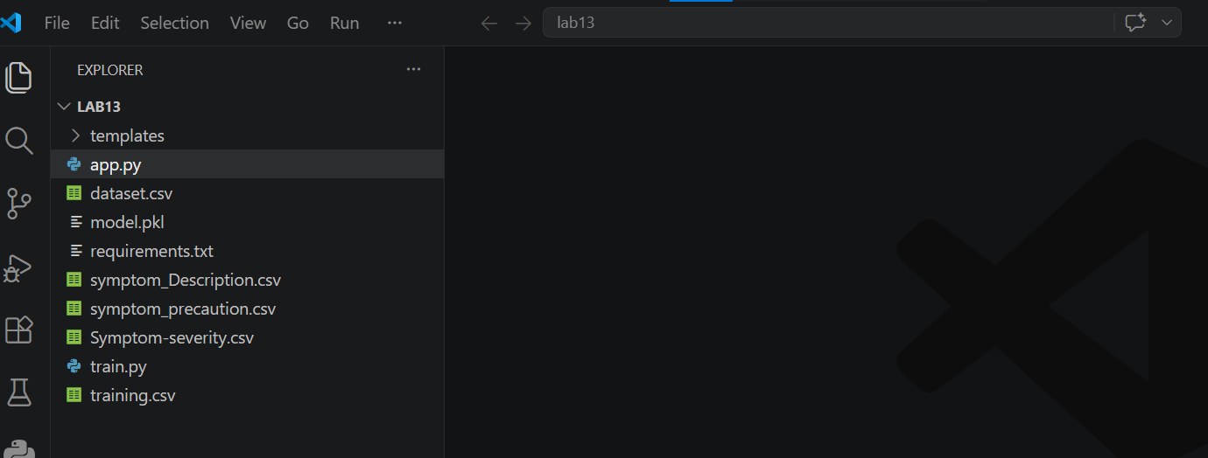

2. Problem Statement
Many people cannot immediately consult doctors. This system provides quick predictions using AI.

3. Objectives
- Predict disease from symptoms
- Use NLP for text processing
- Provide precautions and descriptions
- Build a web interface

4. System Architecture
User Input → NLP Processing → TF-IDF → ML Model → Prediction → Output
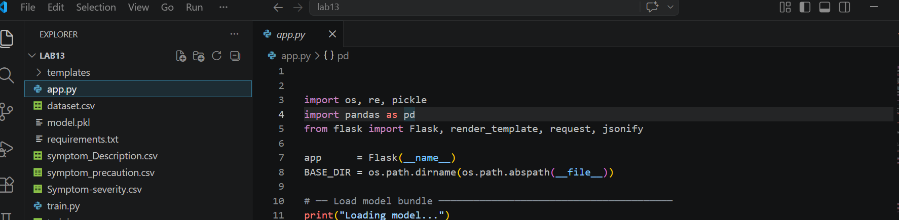

5. Dataset Explanation
The project uses multiple CSV files:
- dataset.csv: training data
- symptom_Description.csv: disease descriptions
- symptom_precaution.csv: precautions
- Symptom-severity.csv: severity weights
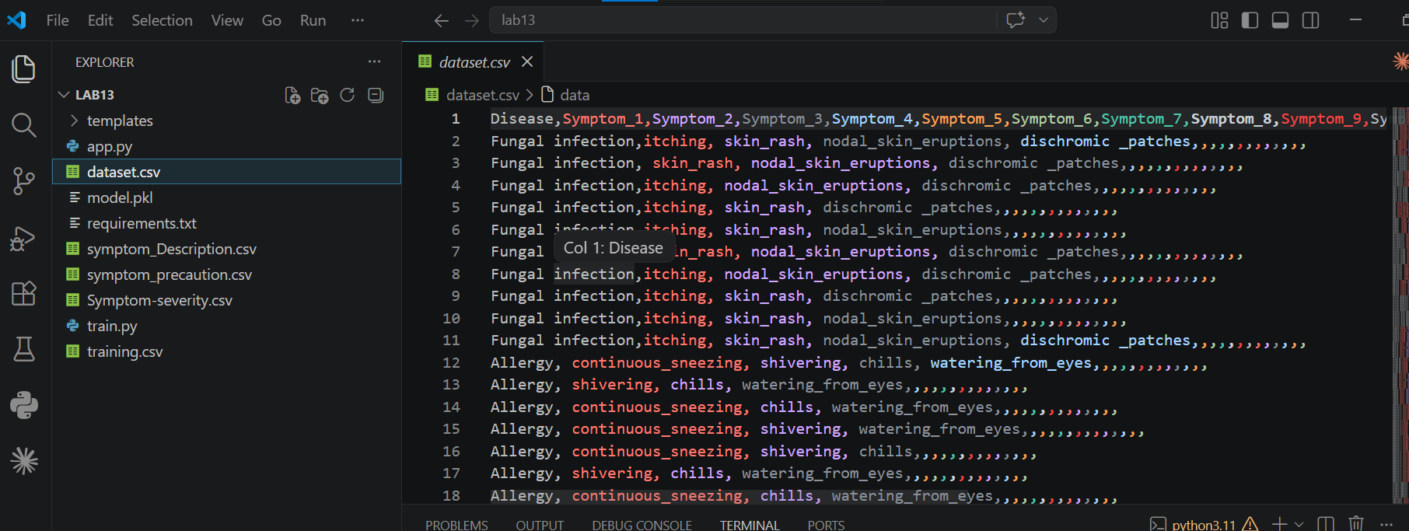

6. NLP Processing
Steps:
- Lowercasing
- Removing special characters
- Tokenization
- Stopword removal
- Lemmatization
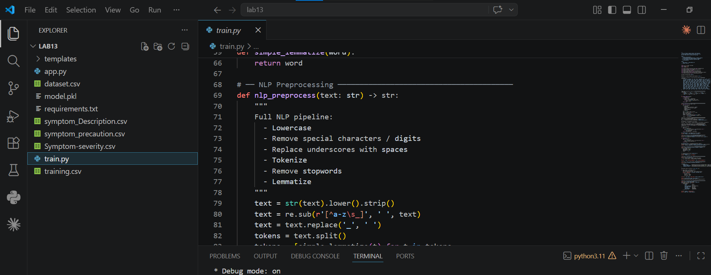

7. Feature Engineering
TF-IDF is used with unigrams and bigrams to convert text into numerical features.

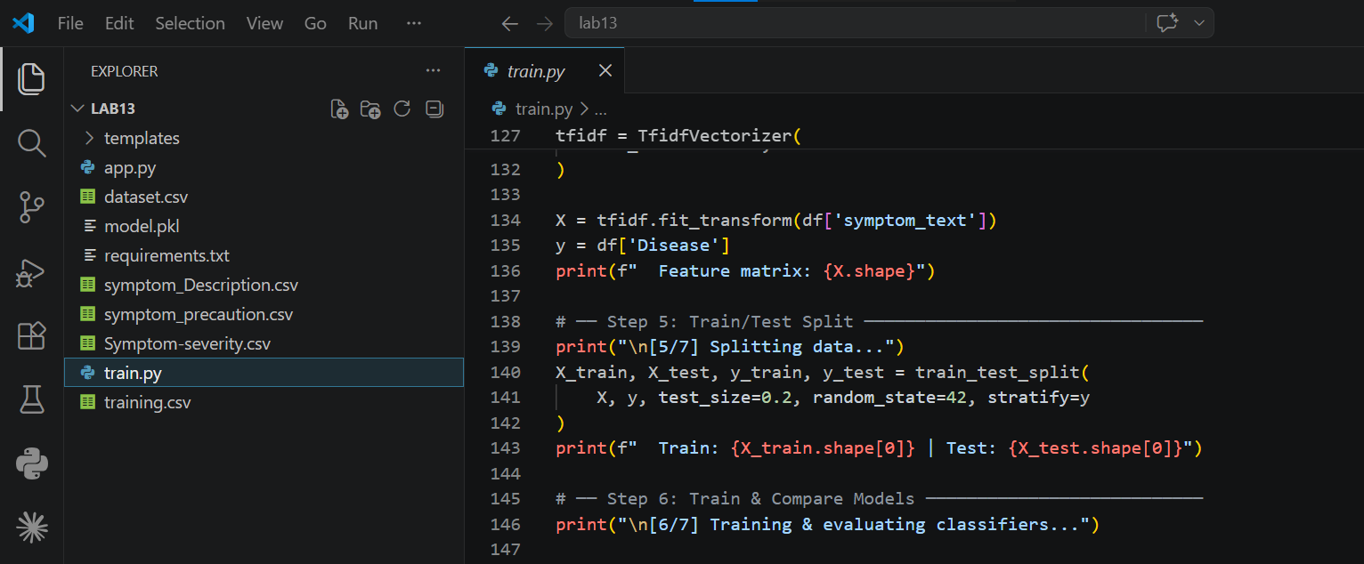

8. Machine Learning Models
Models used:
- Random Forest
- Logistic Regression
- Linear SVC
Best model selected based on accuracy.

9. Training Process
Dataset is split into training and testing. Models are trained and evaluated using accuracy.
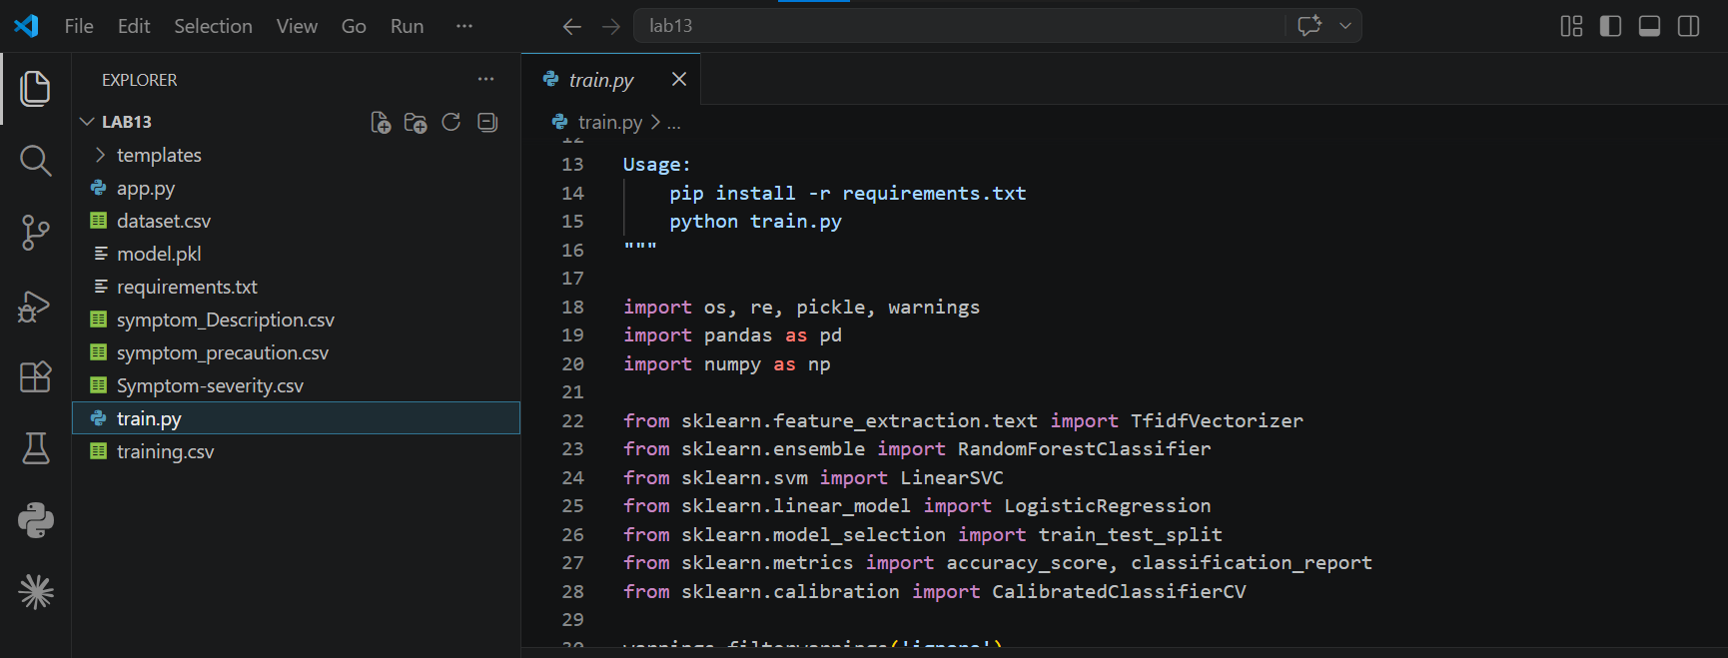

10. Model Saving
Best model is saved as model.pkl including TF-IDF and severity data.
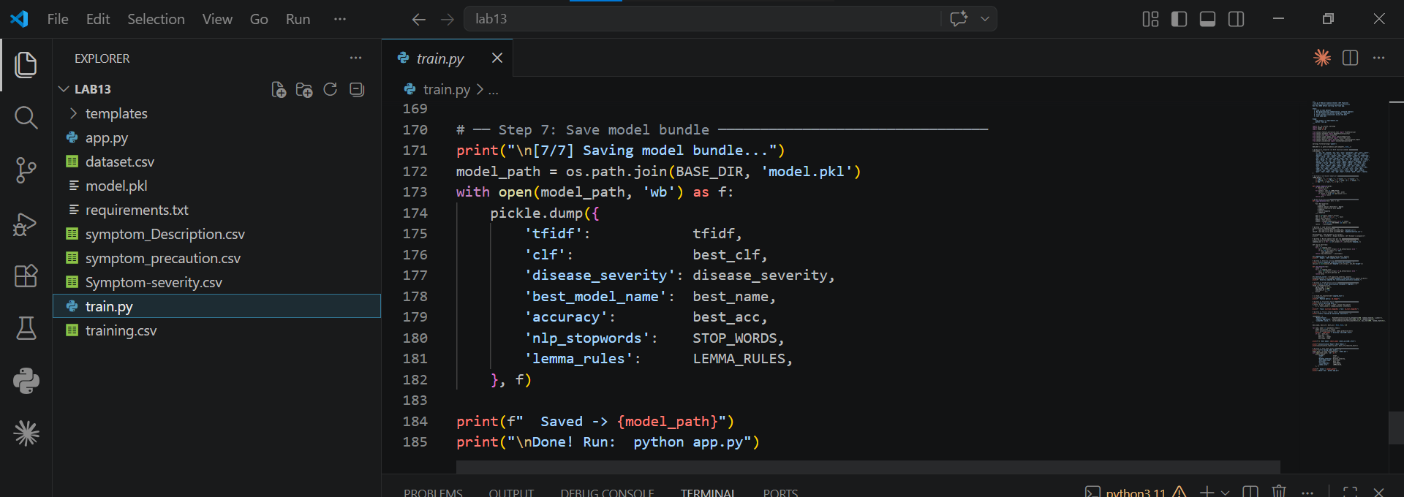

11. Flask Application
The web app loads model and provides endpoints:
- /predict
- /health
- /symptoms-list
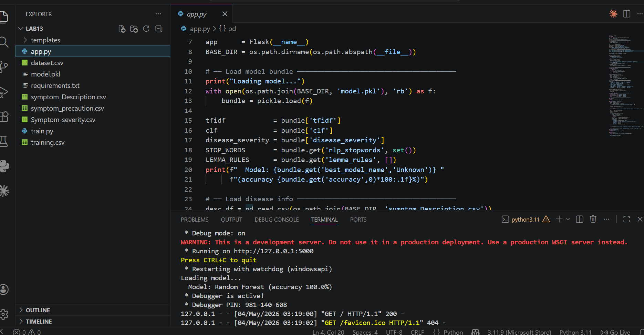

12. Prediction Flow
User enters symptoms → preprocessing → vectorization → prediction → results displayed

13. Output
System returns disease, confidence, severity, description, precautions.
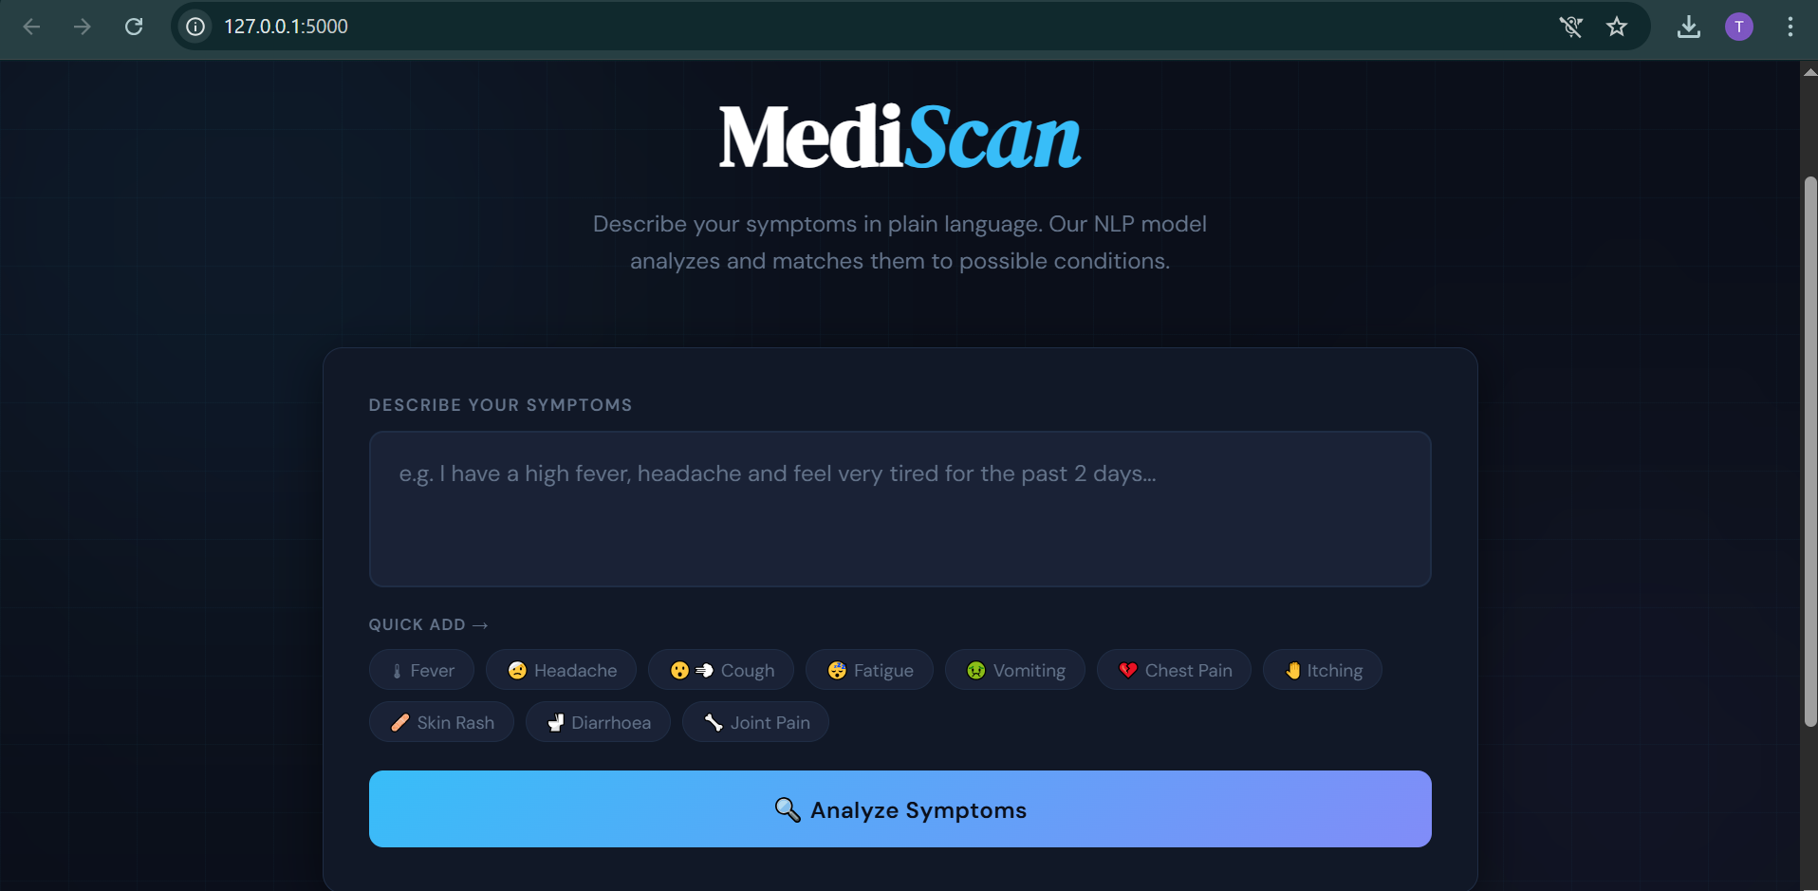

14. Advantages
- Fast prediction
- User friendly
- No need for medical knowledge

15. Limitations
- Not 100% accurate
- Depends on dataset quality

16. Future Improvements
- Deep learning models
- Better UI
- Real-time doctor integration

17. Conclusion
This project demonstrates practical use of NLP and ML in healthcare.

